
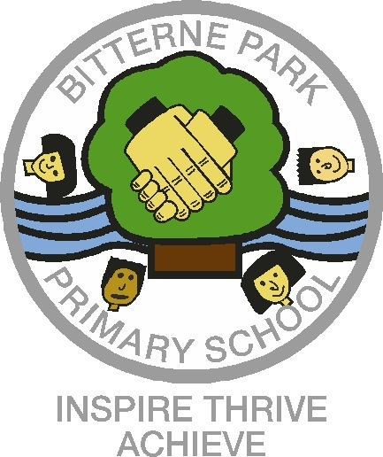
Bitterne Park Primary School
March 2023 Newsletter
Inspire, Thrive, Achieve

Dear Parents

Spring has truly sprung at Bitterne Park Primary School and the sound of quacking fills the corridors!
As I am sure many of you will have heard, we have 5 little ducklings that have hatched in Year 2. The children have named them Lemon, Cocoa, Chocolate, Barney and Bambi. We have had a great time looking after the duckings. We gave them their first bath and they absolutely loved it, diving under the water and even splashing some of the children. The Year 2 children have been learning how to care for the ducklings as part of their learning in Science.
Cross Country Championship Successes!
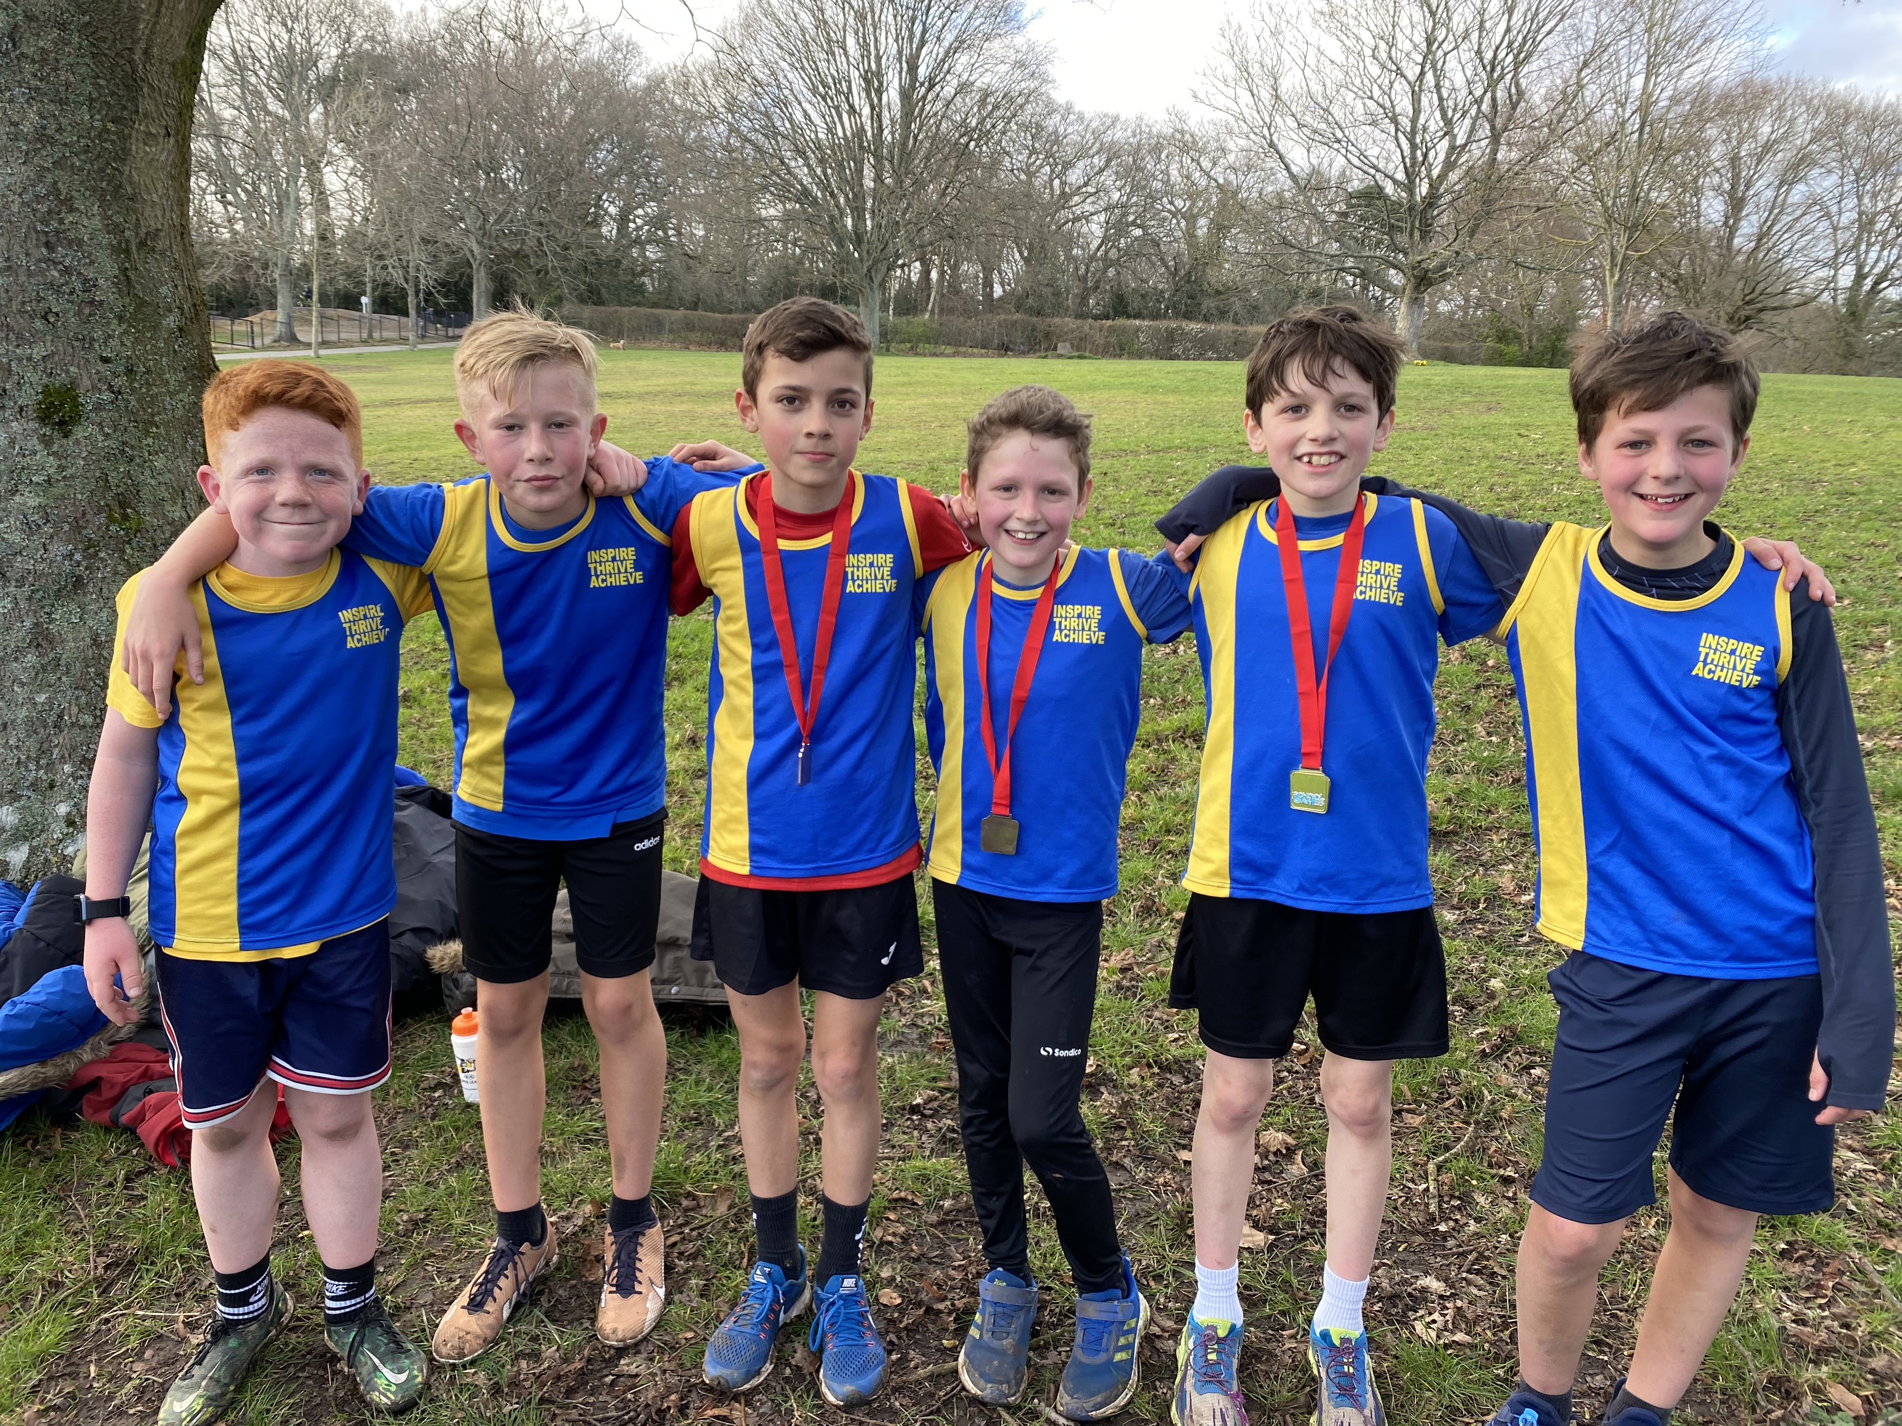
Some children from Years 3 to 6 have been representing Bitterne Park Primary School in the Lower and Upper School Cross Country Championships. These events have taken place at Southampton Sports Centre and the children were really excited to wear their Bitterne Park running vests and represent our school. Both the boys and girls ran incredibly well in both championships and we have had some fantastic results, including three of our children taking 1st, 2nd and 3rd place in the Upper Boys event, out of almost 100 children, meaning the team came 1st overall! The girls performed just as strongly, securing 4th place. What an achievement from all of our competitors! Everyone should be very proud of their achievements!
Please take a look at our website blog for quotes from children and parents.


School of Sanctuary
The children have continued their focus on welcoming others by filling the school with orange hearts, a symbol representing compassion for people fleeing war.

The children have also explored the different languages spoken in their classes and have linked this to our house competitions for this half term, learning how to say hello in these languages. We have certainly enjoyed hearing all the different languages.

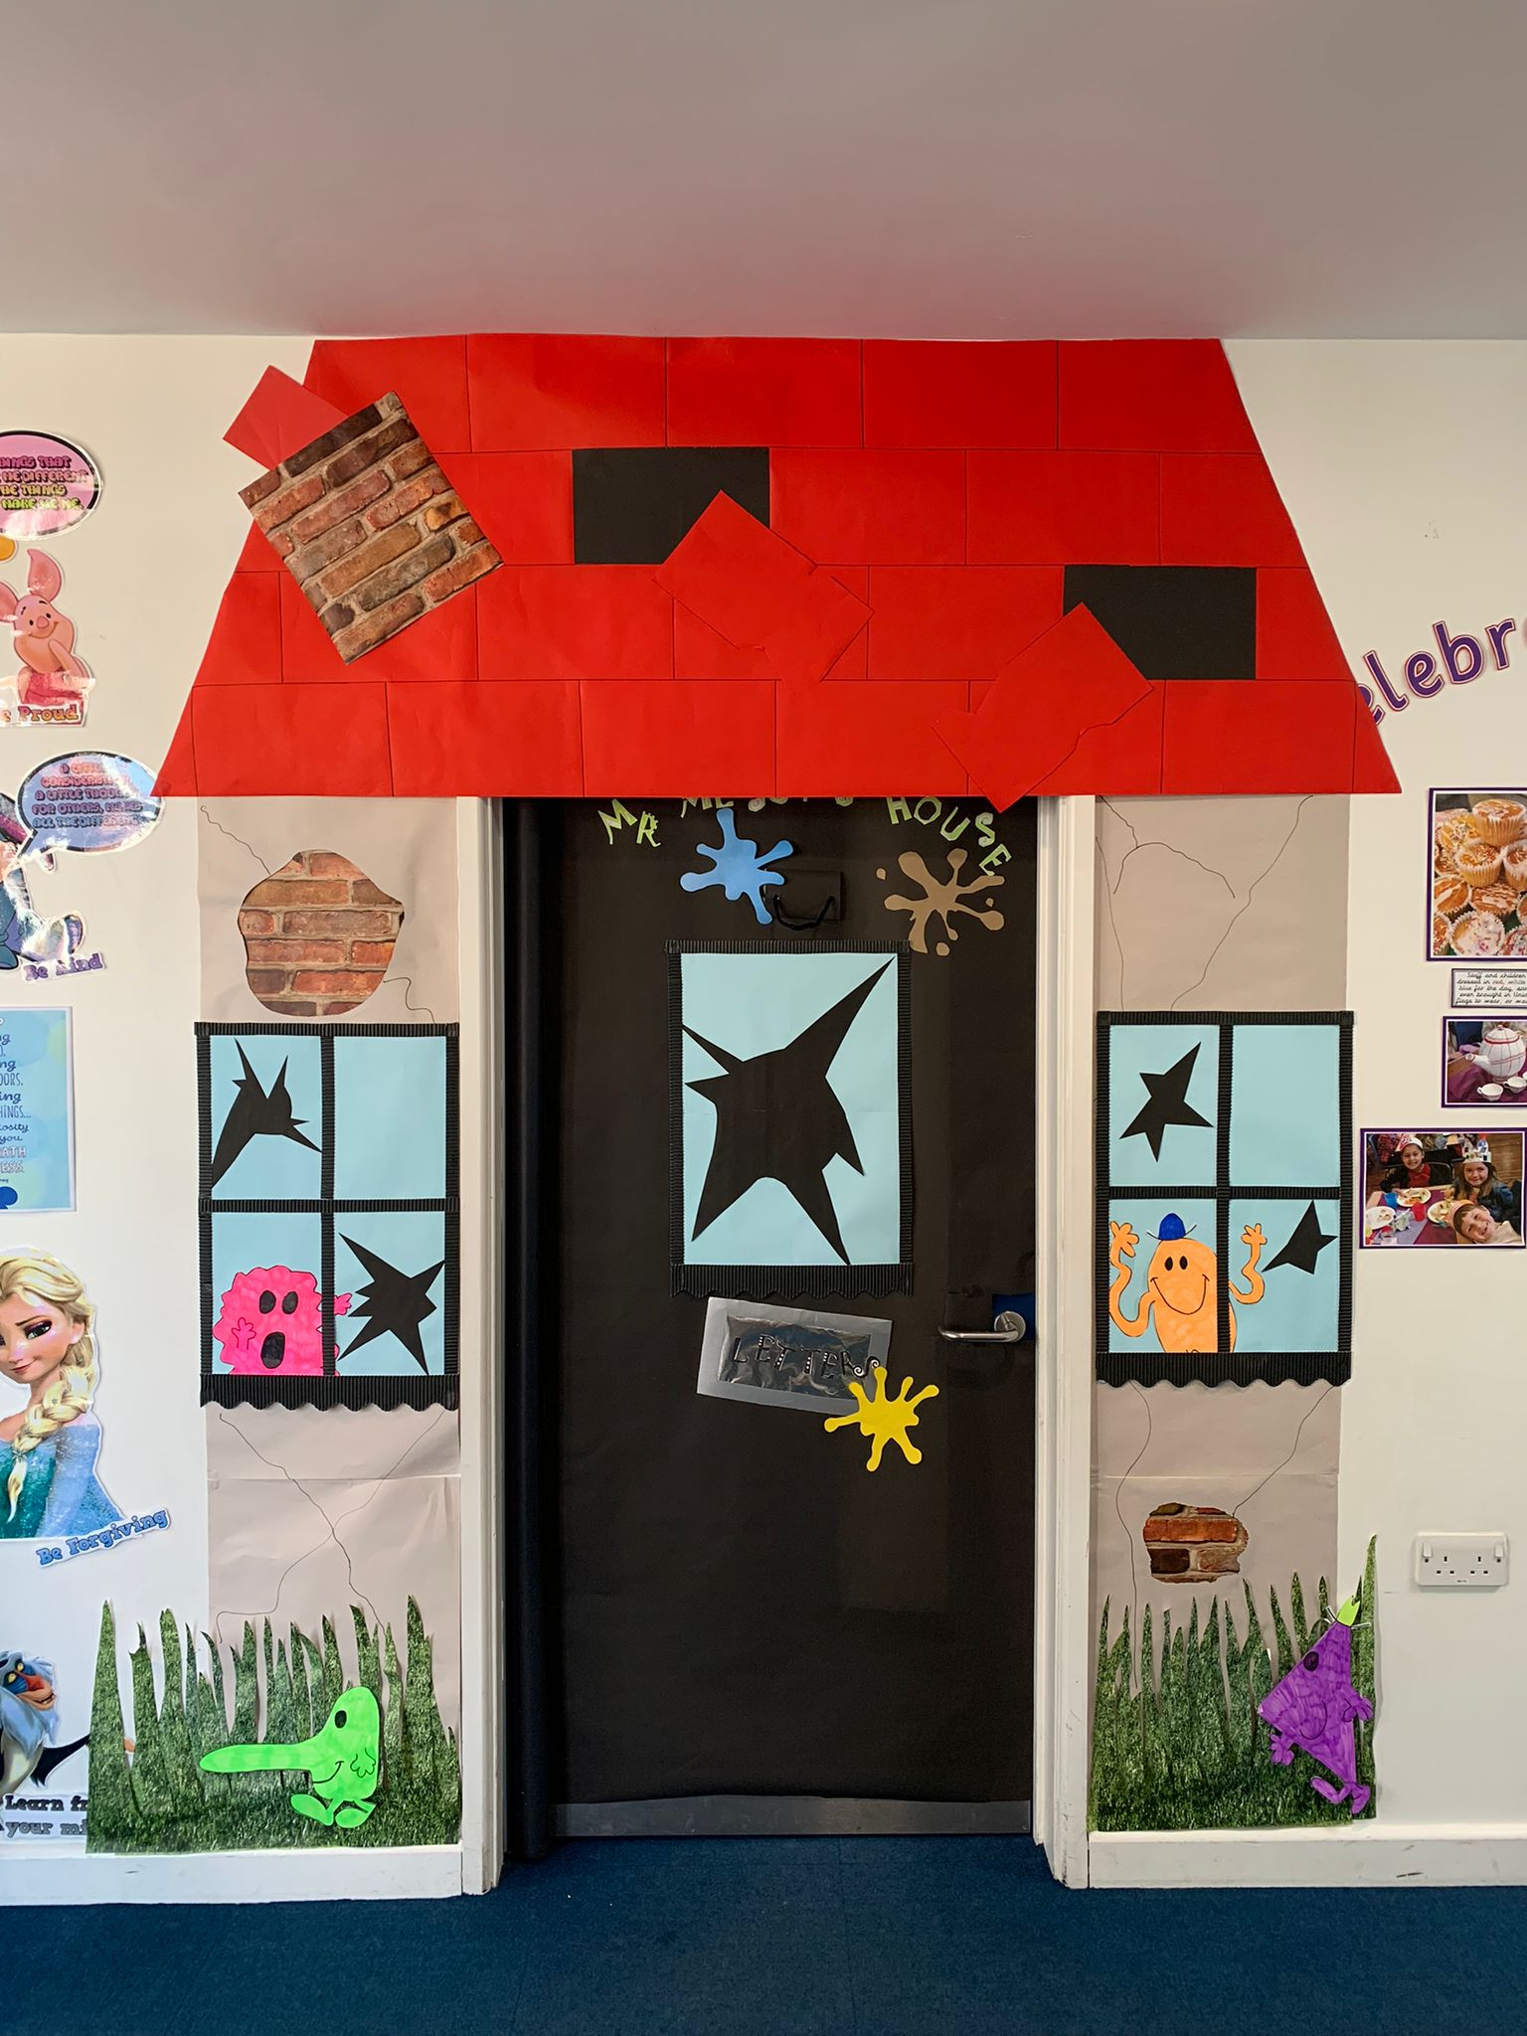
World Book Day
The children and staff all enjoyed World Book Day, as they do every year. A great chance for them all to dress as their favourite characters and for the teachers and support staff to decorate their classroom doors based on a favourite book. The winning door this year was ‘Mr Messy’s House’ which was created by our lovely office team.
Our “Bookface” competition was a huge success again this year, with the children merging themselves into the covers of their favourite books.
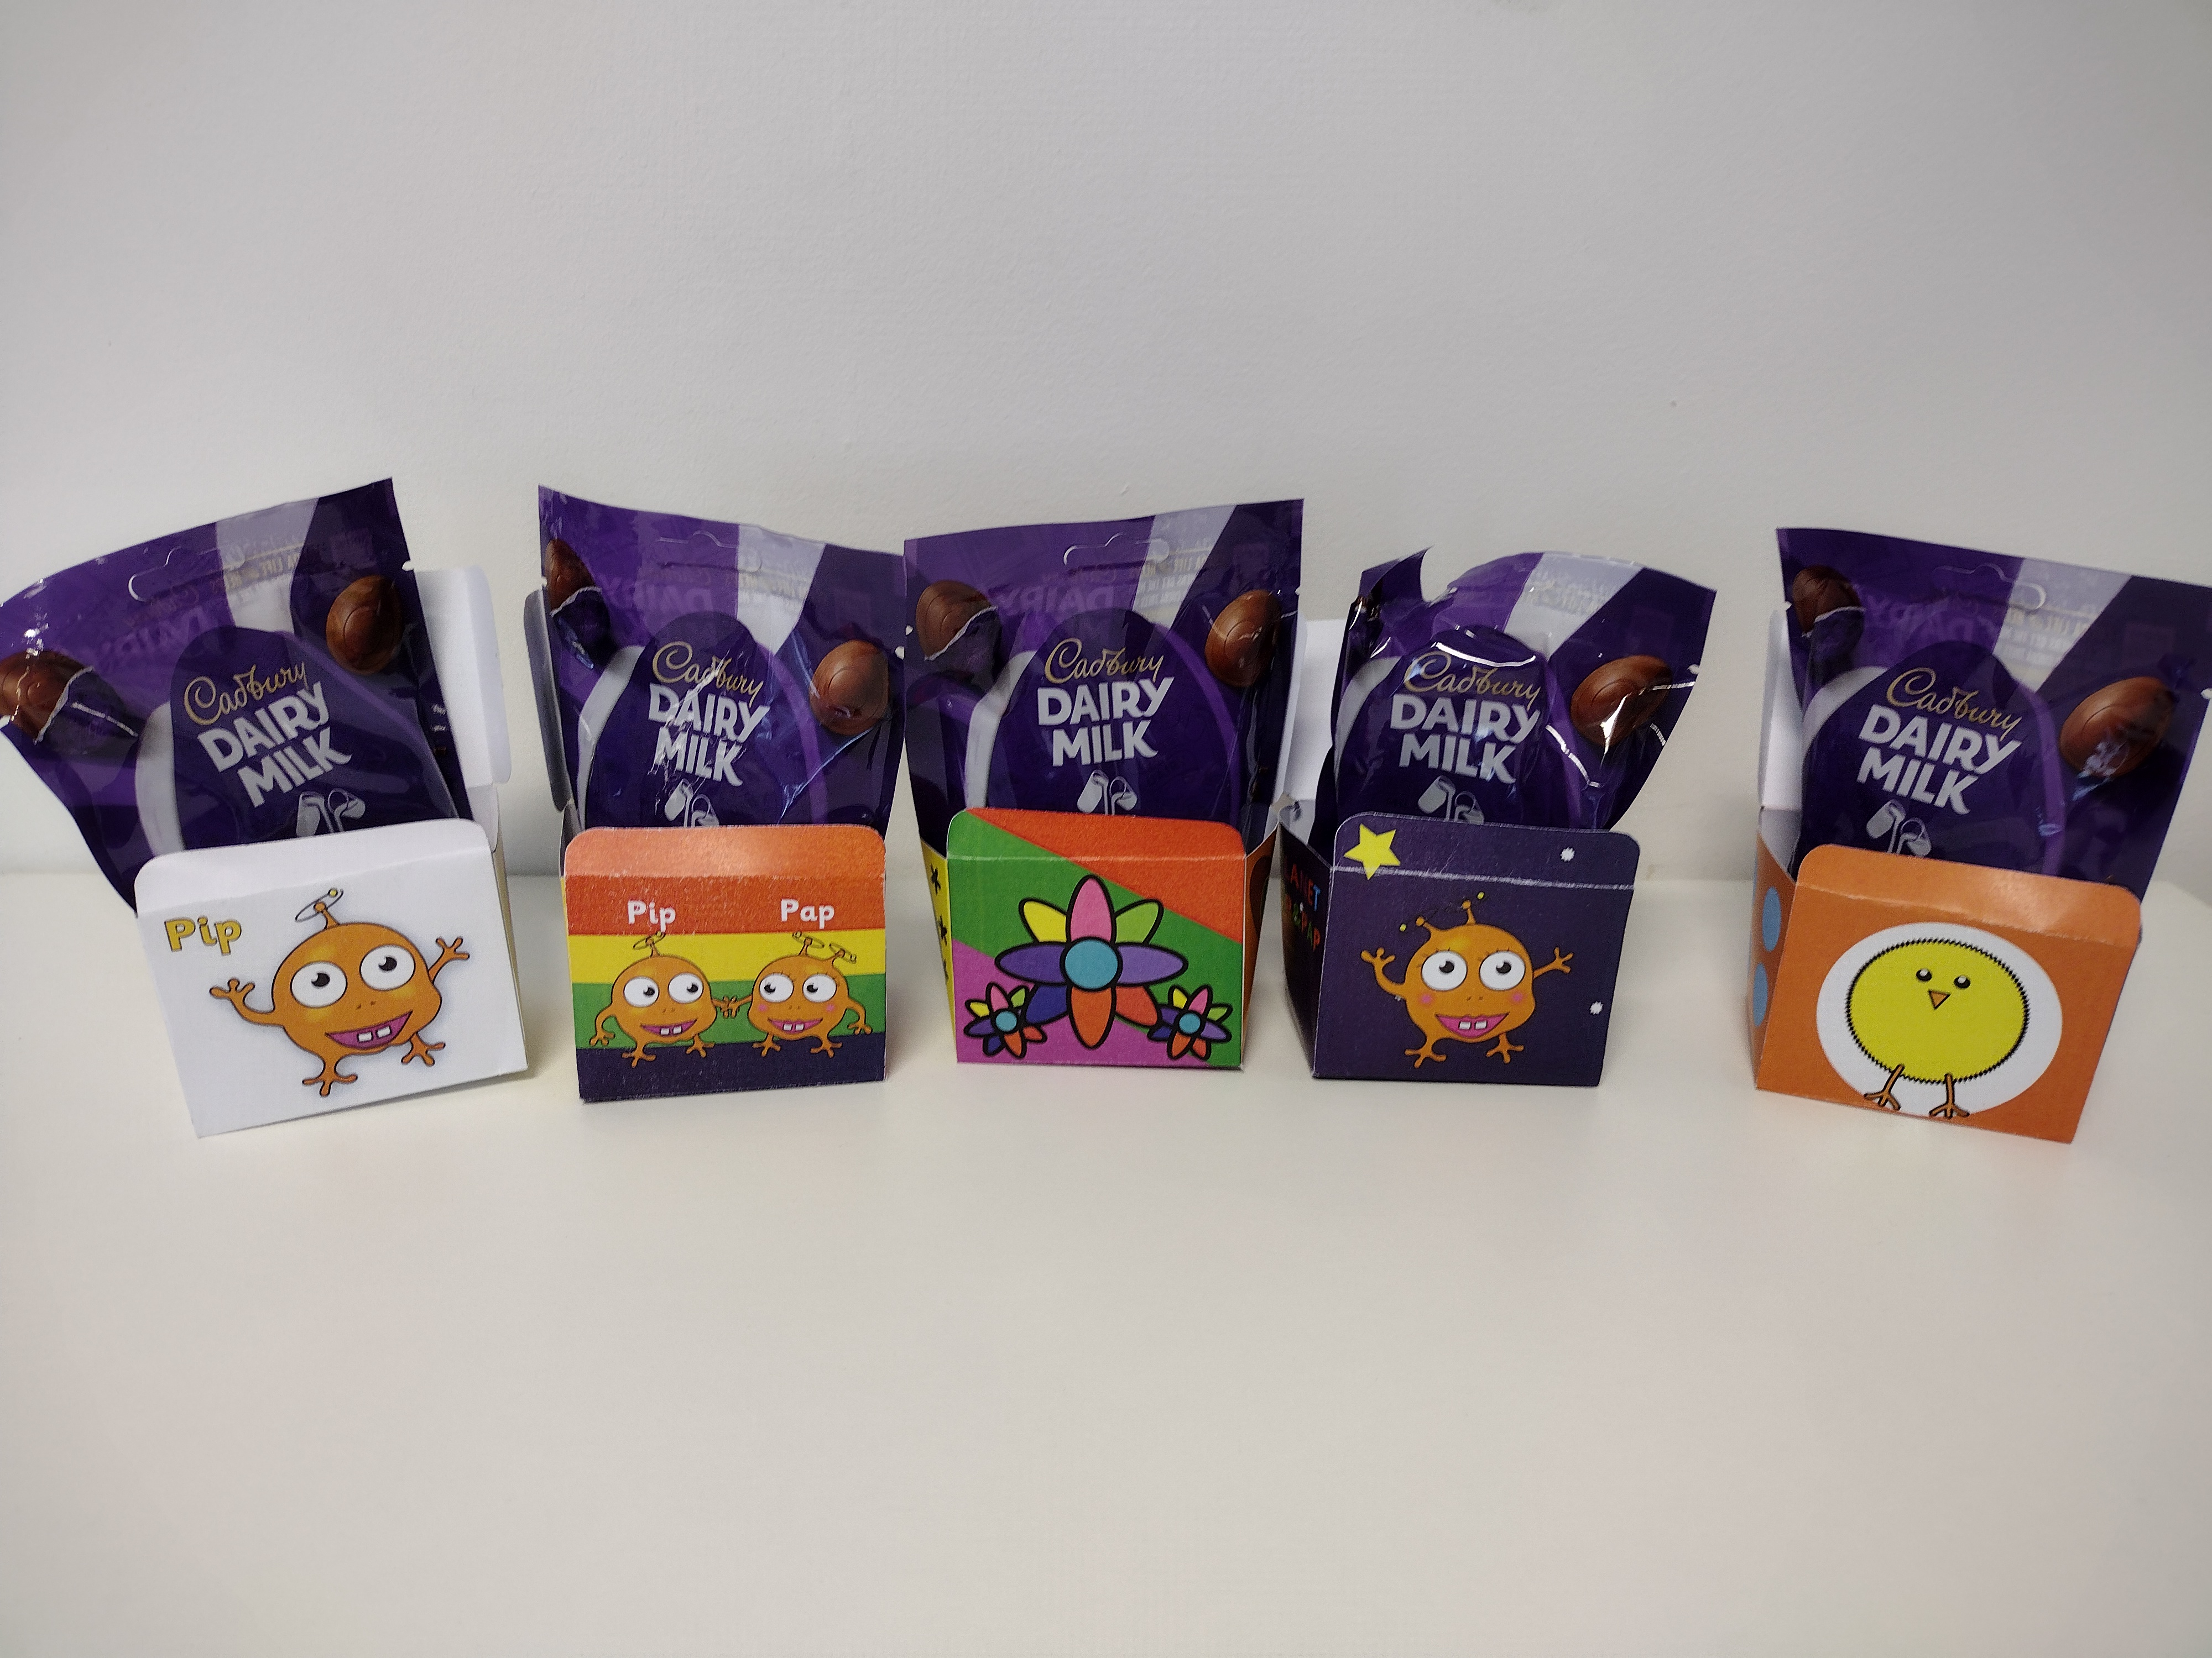
We also had a very exciting competition for Year R and KS1 to design a new ‘Pip and Pap’ alien character. The winning designs will be turned into a book character! Congratulations to Orla (Year R) for winning the Easter Egg Design Competition for Bitterne Park. Here are the winning entries from each of the partnership school.

School Council update
Our school councillors have been busy this half term participating in different projects. In preparation for the upcoming Coronation, the school council members have used pupil voice to collect fantastic ideas from their classmates about potential ideas and activities to mark the momentous occasion. These imaginative and helpful ideas have been shared with school leaders in preparation for exciting events next half term!

On Wednesday 15th March, members of our school council visited the Southampton Civic Offices to address the Lord Mayor, Sheriff and local councillors about the urgent need to instate a safer crossing on Manor Farm Road. Three children bravely addressed the council as part of the 'deputation' process and were met with a standing ovation at the end! The children spoke confidently and clearly as they expressed concerns about safety in our local community during their 7 minute allotted time. Our Year 5 school councillors were also in attendance to support and cheer on our Bitterne Park speakers from the viewing gallery. We are very proud of the children's brave efforts at raising their voices to be heard and look forward to continuing this exciting, important project next half term!

ECO Warriors Update
What a week for Bitterne Park!
We had the pleasure of welcoming the RSPB and WWF into school in order to support their #NatureForSchools campaign. We thank our Eco warriors for all of their hard work during the day and look forward to the whole school joining them in creating different environments to encourage wildlife onto our grounds.
Our children have been busy propagating seeds in classrooms this half term ready for planting as we welcome the summer. We are so excited and wait in anticipation to see the wide variety of produce and flowers bloom over the coming months.
All of our children have also been given a 'plug' of seeds to take home and we would love these to be propagated at home and brought back into school for planting on our Great gardening day on Friday 9th June. We are so excited by all the wonderful gardening going on and are definitely looking forward to seeing the grounds bloom and buzz!


PTFA News
At the end of the term, we had another very successful film club, run by our fantastic PTFA. Thank you to everyone who supported in the running of the event. We look forward to the upcoming disco next half term!

House Competitions
Knowledge –
Being a school of Sanctuary we celebrated the diversity of our children through a knowledge competition about languages of the world. We were challenged to present our knowledge of different greetings and salutations in other languages to show that we welcome and accept any and all who are seeking sanctuary.
1st Dragons
2nd Centaurs
3rd Phoenix
4th Unicorns

Charity – Collaborative Art Piece
A huge thank you to everyone who has brought in materials for our house art projects, The children have been working incredibly hard to create some absolutely fantastic art projects, which are very nearly finished. The children should be super proud of their efforts and as you can see the art projects look brilliant.

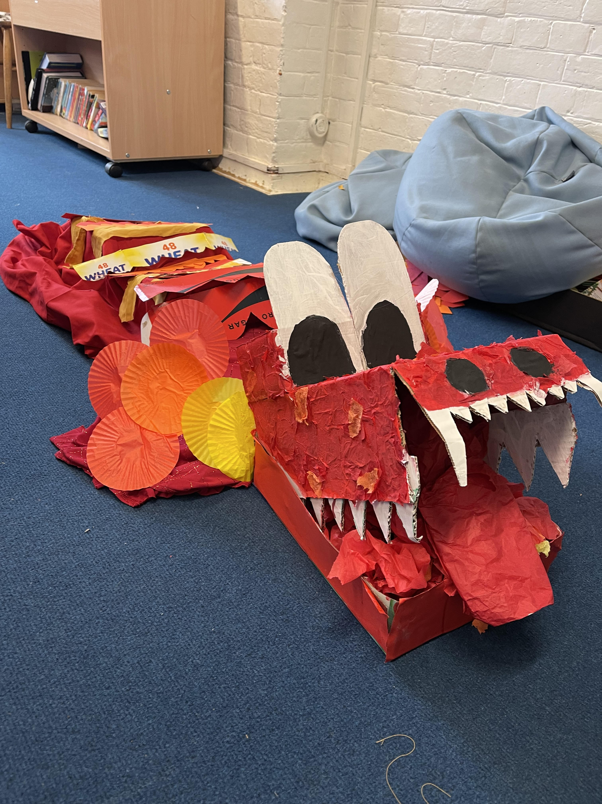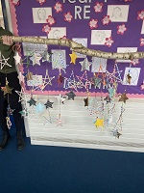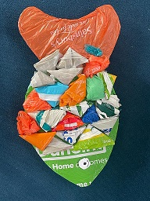
Sports – Netball
This half term saw our children take part in an inter house netball competition. Children competed in houses against each other in a round robin style tournament. Children showed fantastic ability, effort and perseverance, both as individuals and as a team. There was also some great sportsmanship on show from all years.
1st – Centaurs
2nd – Phoenix
3rd – Unicorns
4th – Dragons

Curriculum and Enrichment

Year R
Busy Bee: This term in Year R we have been eco warriors. We have been tending to our gardens and started composing!
Literacy: In literacy we have been learning about farms. We have explored different books such as Monkey and Me, Three little pigs and what the ladybird heard. We are now able to retell a story.
Phonic: In phonic we are beginning to secure our learning in pink phase and exploring pink phase spellings. We love showing our grown-ups our spelling work every Friday in our workshops.
Maths: In maths we have been learning about money, estimation, doubling and halving. We created our own doubling machine and explored it in Busy Bee.

Year 1
A mouse took a stroll through the deep, dark woods…. And saw some amazing year 1 Writing! You guessed right, year 1 have been delving deep into the wonderful world of the Gruffalo! After recapping the story and making some actions to help us remember the sequence, we explored a wide range of adjectives that could help us describe the different sneaky characters that the mouse would meet along the way. We used the structure of the Gruffalo to create our own narratives with our very own mean character! AHHH! Be careful… Its favourite food is year 1 yoghurt!

Year 1 are WILD about animals! Building on our knowledge of animals and their classifications, we have been learning all about what animals eat and how it helps their bodies in Science. We had a great time learning all about our key topic words ‘carnivore’, ‘omnivore’ and ‘herbivore’, especially in our first lesson where we became mini-scientists and explored some pretend animal poo, making inferences on what diet they have! We drew all of our knowledge together to be the owners of our very own zoo or farm. We had to work out what food to order for each animal and explain why this would be best. Year 1 are ROAR-some!

Year 2
Year 2 has had a wonderful half term. We have been writing about mythical creatures and are currently writing an exciting adventure story. We bet you want to find out more...Tap, tap, tap at the window. Gasp! A strange looking dragon appeared. We wonder what the cheeky, naughty dragons are up to! Ask the Year 2 children and they will be able to tell you about the dragons in their own exciting story!

Quack, quack! With the exciting arrival of ducklings in Year 2, the children have been very keen to learn more about the life cycle of a duck. Their enthusiasm and the scientific questions asked have been fantastic! After learning about the hatching process and being able to name our new arrivals, the children have had the opportunity to hold a duckling and watch them have their first swim.

In History, we have been learning about Florence Nightingale and the incredible impact she has had on the world of nursing. The children have been able to identify what life was like for a soldier before, during and after Florence. It is great to see the children so invested in their learning! Keep up the great work Year 2!

Year 3
Year 3 have had an amazing half term filled with lots of new knowledge!

In our writing lessons, we have been exploring 'Guess Who's Coming For Dinner'. We have become detectives and made incredible inferences using the clues from the pictures. We then used this understanding of the characterisation to write a formal invitation inviting the main characters to Dr Hunter's lair (I mean, home!). Filled with play on words that hint towards Dr Hunter's true intent and incredible language choices, our invitations are a pleasure to read! In science, we have been learning about the life cycle of a flowering plant. We particularly enjoyed learning about pollination and linked this to our very real world issues around bee survival. Our children have been incredibly inspired by this, even bringing in posters made at home. We can't wait to continue to deepen our understanding of plants next term when we learn about plant survival. Finally, in geography we have been learning about climate change. Again, our children have been extremely inspired by this learning which is amazing to see. We have learnt about the causes and impacts of climate change before applying this to write our own speeches inspired by Greta Thunberg and create a powerful piece of artwork.

What an amazing half term! The Year 3 teachers can't wait for next half term!

Year 4
It has been an exciting and busy half term in Year 4! Our writing has been magical and focused on Harry Potter's change in fortunes as he discovers he is a wizard. We have created the effects of: surprise, curiosity and finally awe and wonder. In Maths, we have begun our investigations into fractions and decimals working carefully to understand the concept of them. This has linked to a range of equivalents as well as understanding how they can be added or subtracted.
In Geography and Science, our focus has been rivers and the water cycle. We noticed that water has many different stages and how ready we are for a flood depends very much on how many resources the country has. We learn about these things to prepare us for our future and help us to be ready to become architects of a better world!

Year 5
Year 5 have been making a splash this term with each class doing a week of swimming lessons. The children have been working on their confidence in the water and have really enjoyed practicing their skills. They all received a certificate to celebrate their progress and we are all really proud of them!

Year 6
In geography this half-term, we have been exploring the topic of coastal management systems. Our aim was to gain an understanding of the coastal environment and the importance of managing it sustainably for the future.
During our lessons, children have engaged in various hands-on activities to explore the different factors that impact the coast, such as pollution, erosion, and the effects of climate change. We have also examined the ways in which humans interact with the coastal environment and how this can be both positive and negative.
We have explored different strategies and technologies that are used to manage the coast, such as sea walls, beach nourishment, and the use of renewable energy sources. Through these activities, children have developed an appreciation of the complexity of coastal management and the importance of collaboration and planning to ensure its sustainability. We hope that this learning experience will inspire children to think critically about environmental issues and encourage them to become architects of a better world.

More information about our curriculum can be found at: https://www.bppslive.net/curriculum

REMINDERS
Attendance
Thank you to all those families who work hard to ensure their children are in school every day. Our school target is 97.6% and currently our attendance is at 95.81%. If your child is too ill to attend school please contact the school office each morning that they are away from school so that we can correctly record the reason and so that we don’t worry. Any absence from school without an explanation will be recorded as an unauthorised absence and will be investigated.
Uniform
Please ensure all uniform is clearly labelled with your child’s name so that we are able to return any lost property to your child as and when it is found.

Allergies
Can we please remind you that we have a number of children and staff with severe nut allergies. With this in mind, we do not have any nuts or nut products at snack time or in packed lunches. These include peanut butter, Nutella or Pesto (which contains Pine nuts). These can be a major cause of anaphylactic shock in some adults and children. Your care and support in this is greatly appreciated.

School meals
Please check out the new Summer term menu from City Catering that will be available after the Easter break. https://static1.squarespace.com/static/62fdf4da171129493b93a7eb/t/6411ba7be2af0531af0b377a/1678883453021/Bitterne+School+%28three+page%29.pdf
School meals are £2.90 per day. Year R, 1 and 2 are all entitled to Universal free school meals. If you think your child may be eligible for free school meals due to your personal financial circumstances please use the below link to run an eligibility check. https://www.cloudforedu.org.uk/ofsm/southampton/

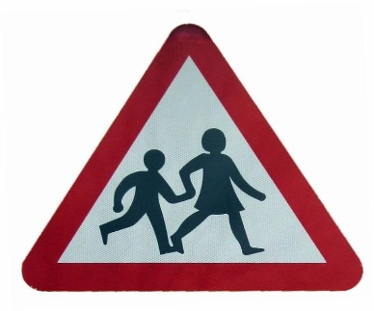
Parking
We are sadly still getting occasional reports from local residents of inconsiderate parking or dangerous driving at school drop off and pick up times. Please be mindful if you need to use your car for the school run. As the weather improves it is a good opportunity to enjoy a lovely walk to and from school. Local residents are advised to contact the Civil Enforcement Officers or the police if they have concerns.

No Dogs on site
Dogs must not brought onto school premises. This includes the playground and the area in front of school just inside the gates. This is a Health & Safety requirement so we would appreciate your full support.

Dates for your Diary
- 3rd April – 14th April – Easter holidays
- Wednesday, 19th April – Year 2 trip to Marwell Zoo
- Monday, 1st May – May Day bank holiday
- Monday, 8th May – King’s Coronation – extra bank holiday
- Tuesday, 9th May – Friday, 12th May – Year 6 SATS Week
- Friday, 19th May – Sports day and family picnic
- Thursday, 25th May – Inset Day
- Friday, 26th May – Inset Day
- 29th May – 2nd June – half term
- Friday, 9th June – Great Gardening Day
- Tuesday, 6th June – 13th June – Scholastic Book Fair
- Monday, 10th – 14th July – Year 6 Residential to Skern Lodge
- Friday, 21st July – break up for the Summer Term
- Monday, 4th September – Inset Day
- Tuesday, 5th September – Pupils return to school

Have a wonderful Easter break.
Have a wonderful last week of Spring Term


Gerida Montague
Executive Headteacher

